Lab Exercise 3- Working with Git Rebase
Lab Exercise: Git Rebase
This exercise demonstrates the use of git rebase in a scenario where no conflicts occur.

Objective
- Learn how to rebase branches when there are no conflicting changes.
- Understand the clean, linear history created by git rebase.

Prerequisites
- Install Git on your system.
- Initialize a Git repository:

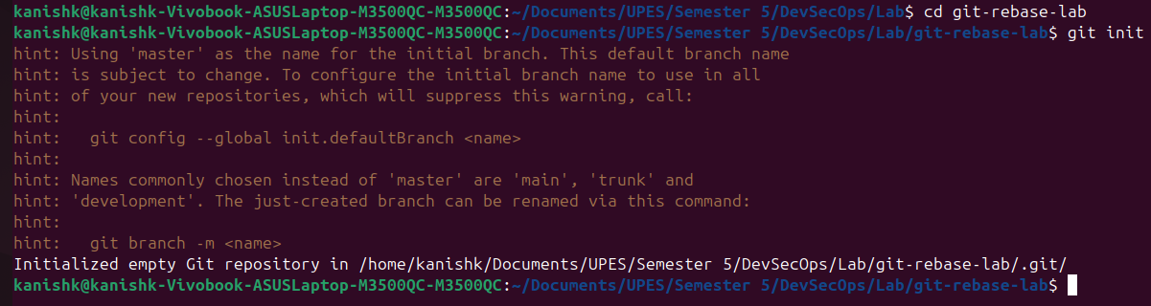
Step-by-Step Instructions
1. Set Up the Repository
- Create the main branch and make the initial commit:
- Create a new branch feature-branch:
- Add a new line to file.txt in feature-branch:
- Switch back to the main branch and add another line:
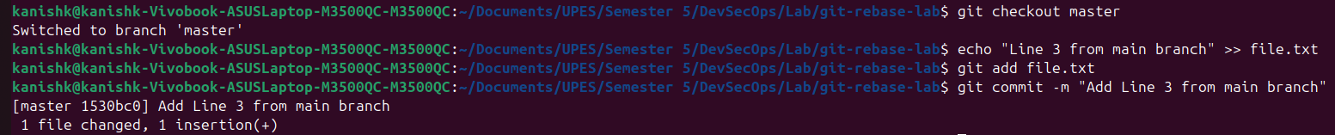

2. Rebase feature-branch onto main
- Switch to feature-branch:
- Rebase feature-branch onto main:
- Git will replay the commit from feature-branch onto the main branch. Since there are no conflicts, the rebase completes automatically.

3. Verify the Rebase
- View the commit history:
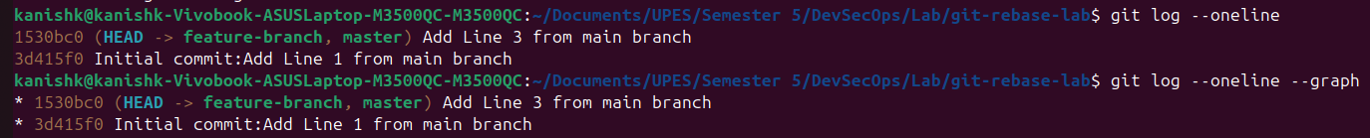
- Check the contents of file.txt:

